**DART ASSIGNMENT NO # 06**

**Q2)**  Write a Dart function that returns a passed string with letters in alphabetical orders.

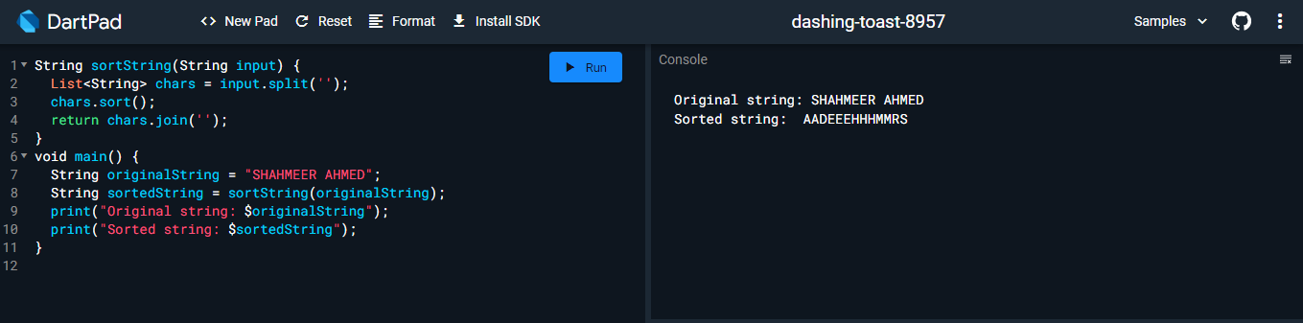

**Q3)** Write a Dart function that accepts a string as a parameter and converts the first letter of each word of the string in upper case

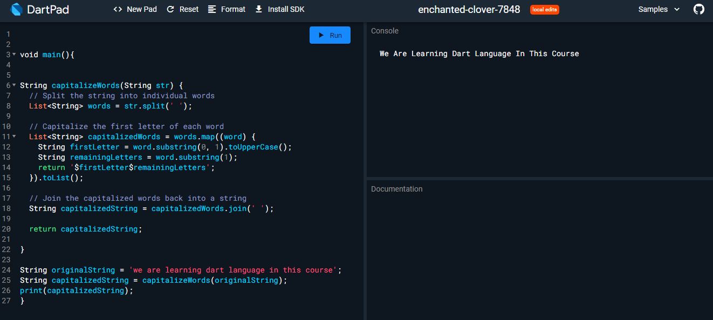

Q4) Write a Dart function which will take an array of numbers stored and find the second lowest and second greatest numbers, respectively.

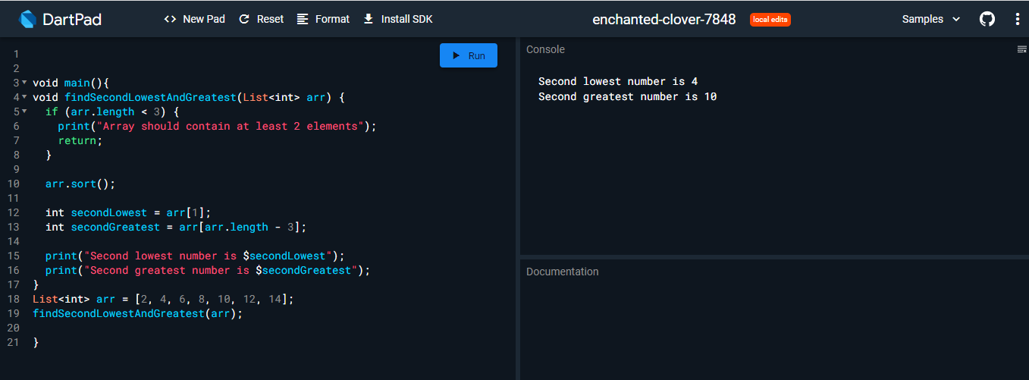

Q5) Write a Dart function that accepts two arguments, a string and a letter and the function will count the number of occurrences of the specified letter within the string.

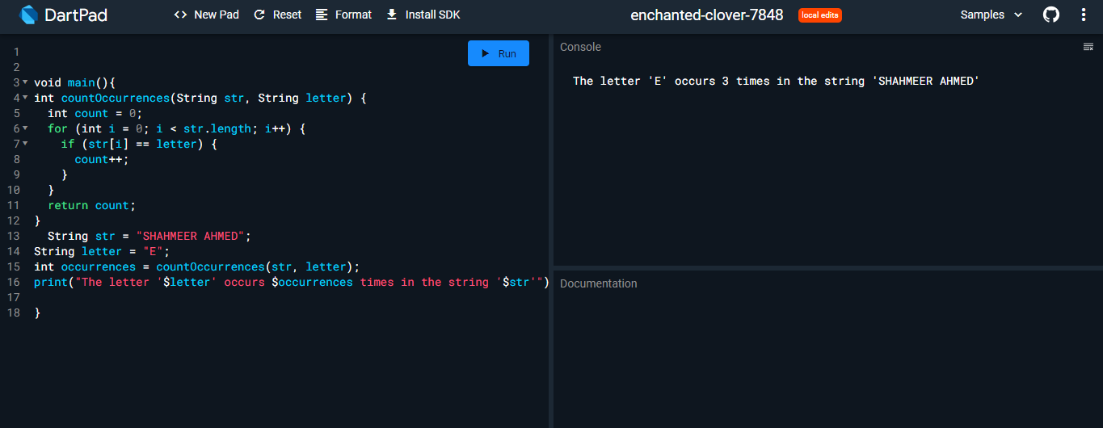

Q6) Write a Dart function that accept a list of country names as input and returns the longest country name as output.